**Employee Management Rest API based web application**

**IDE : Eclipse**

**DataBase : MySQL ; Database name : rmrestapi**

**Spring Boot project with Spring JPA and Spring Security**

1. **Add Role**

http://localhost:8080/addroles

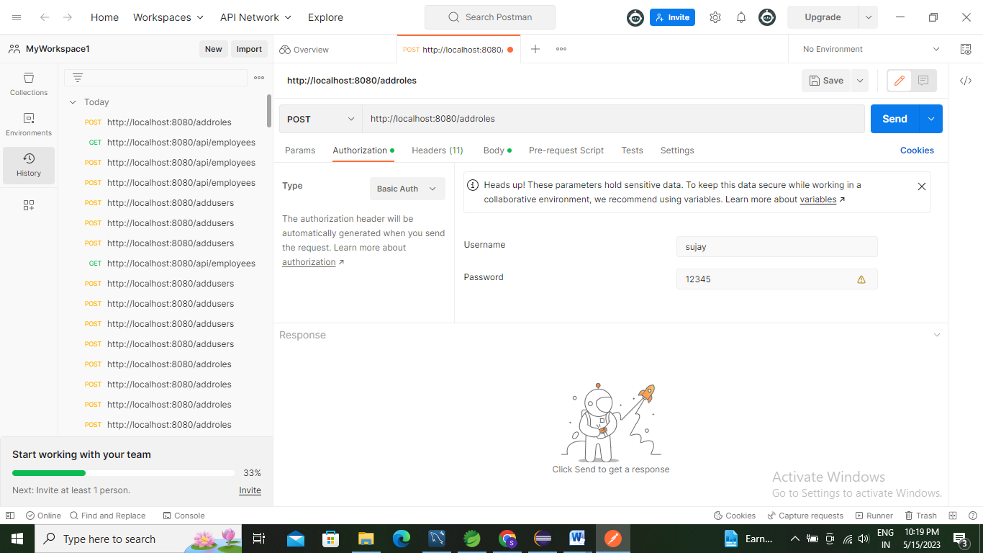

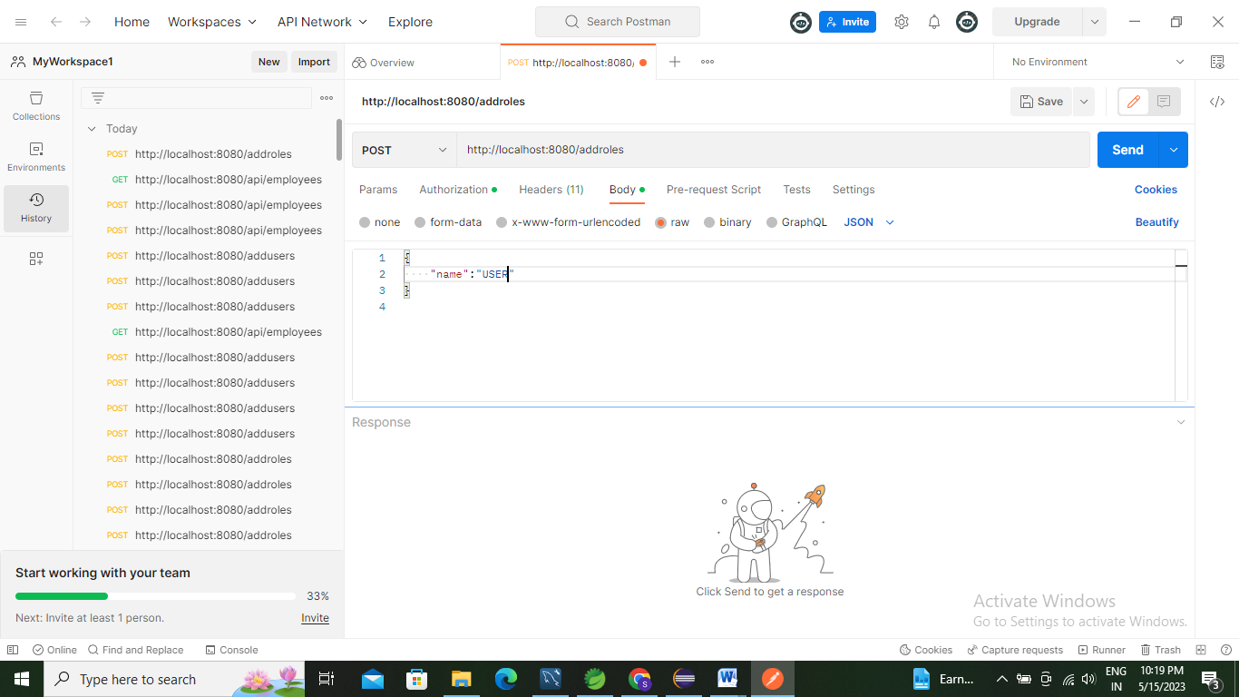

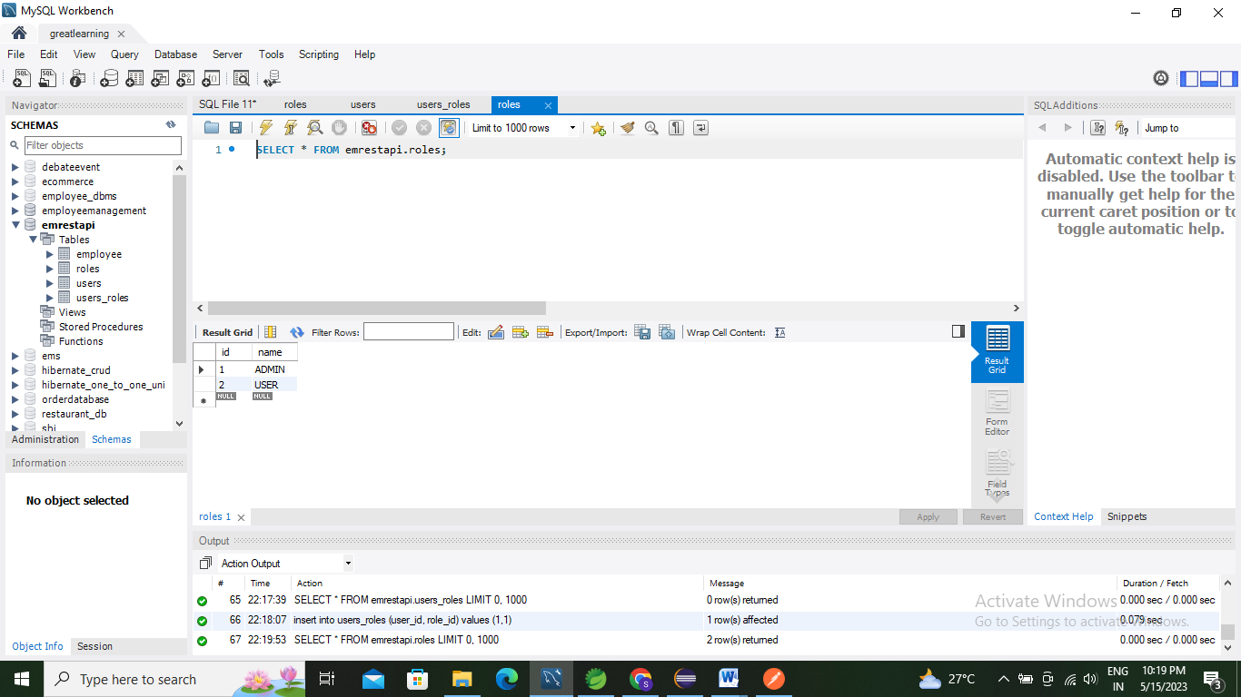

1. **Add User**

<http://localhost:8080/addusers>

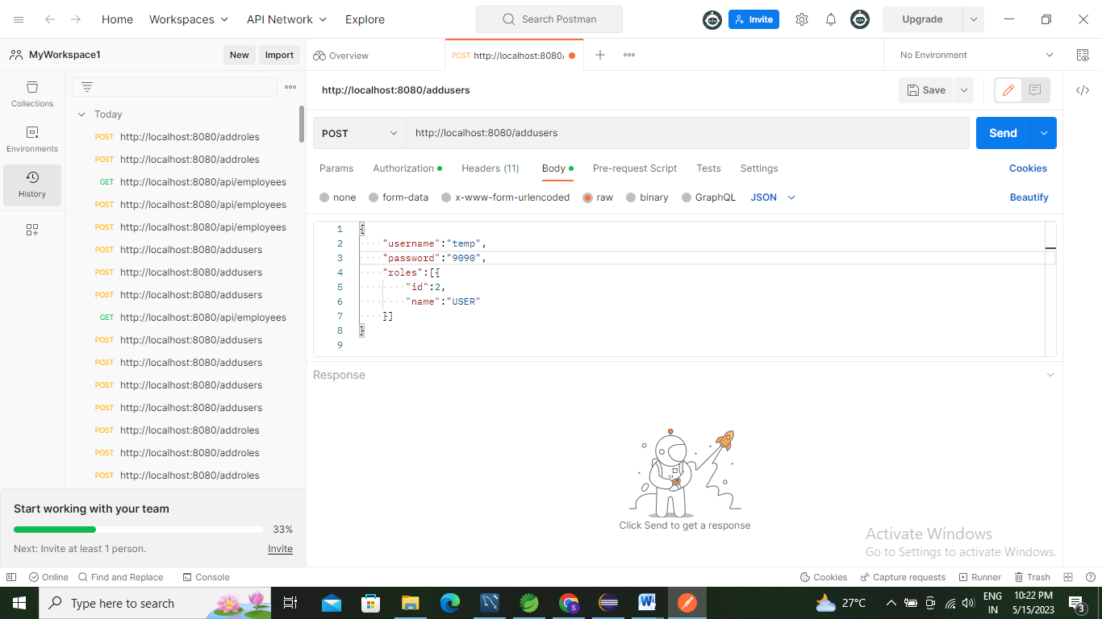

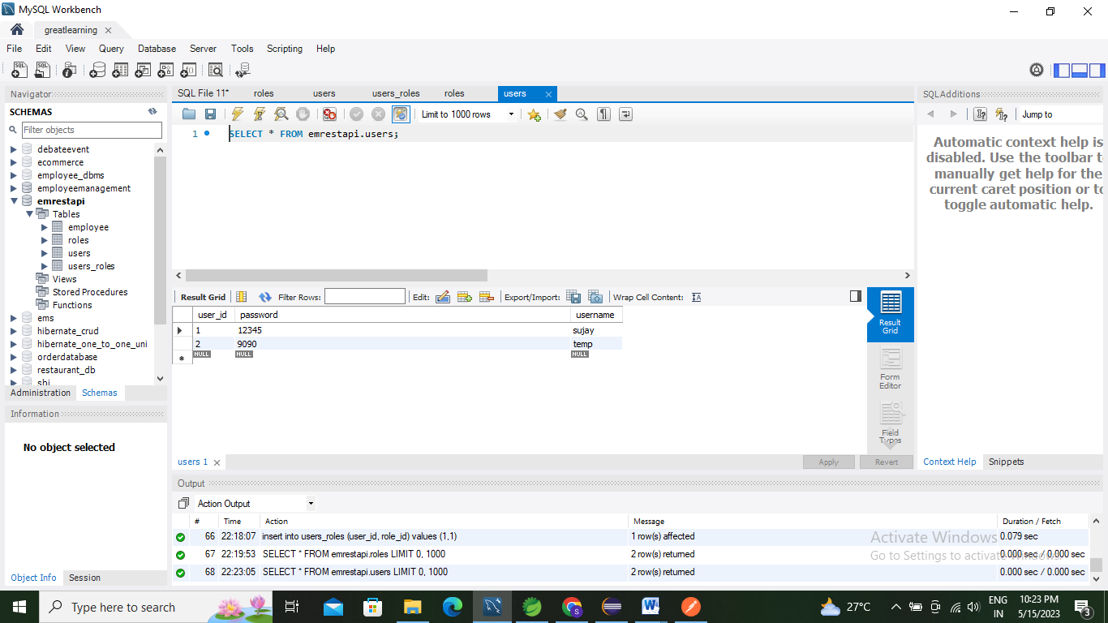

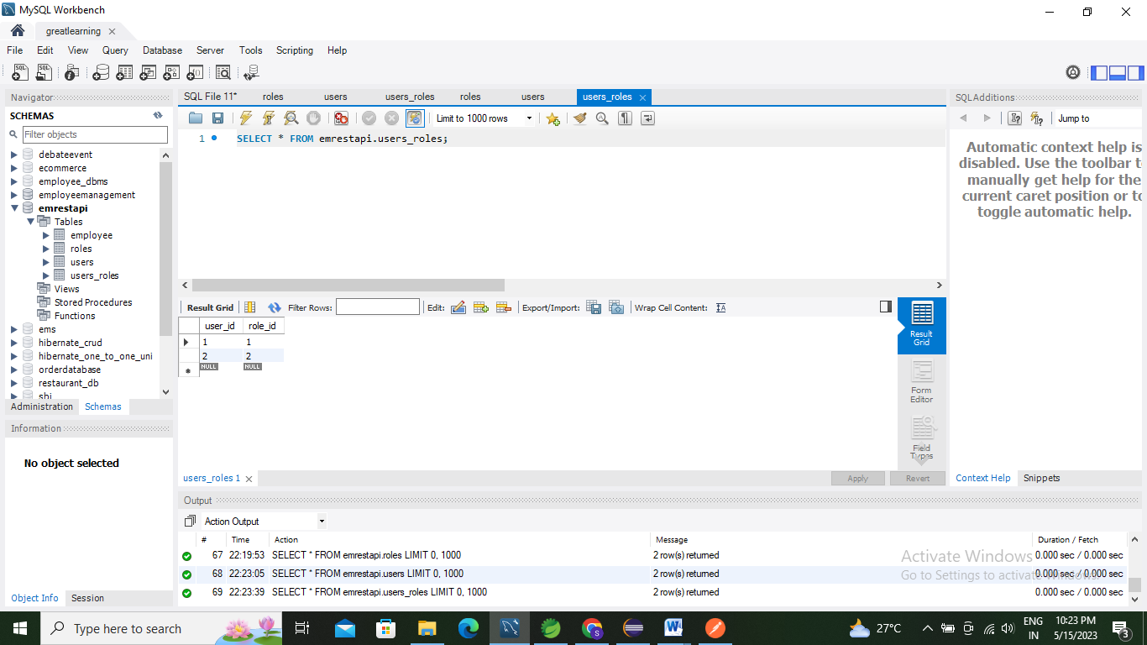

1. Add Employee

<http://localhost:8080/api/employees>

With ADMIN credentials

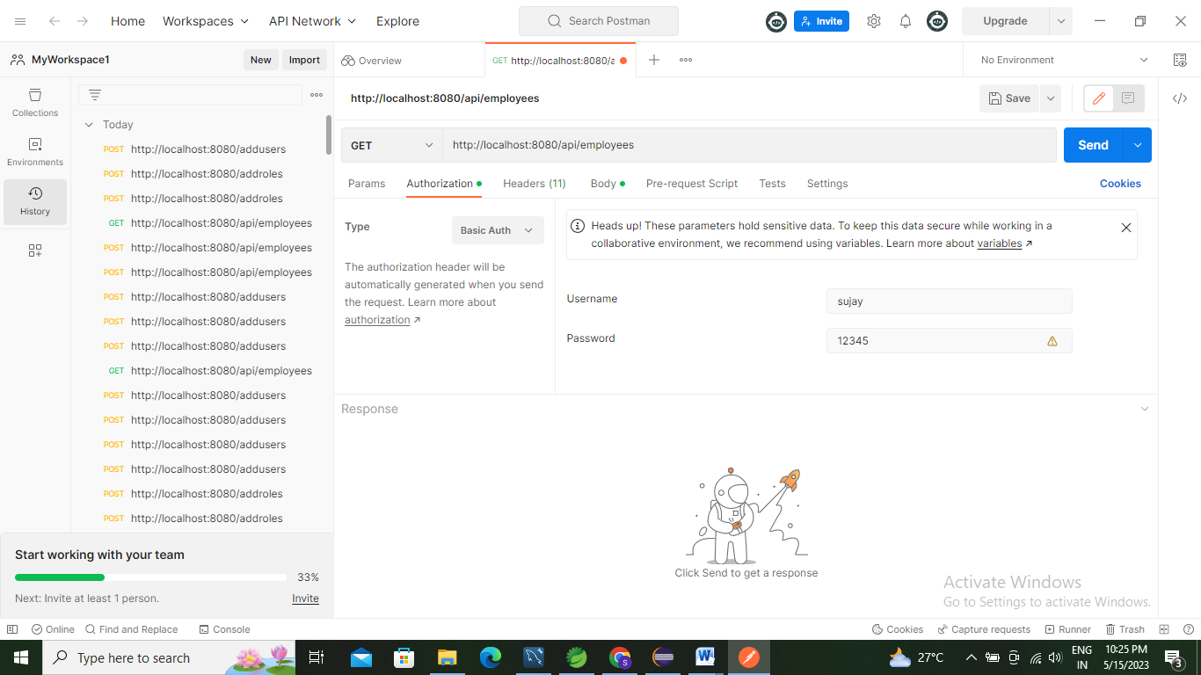

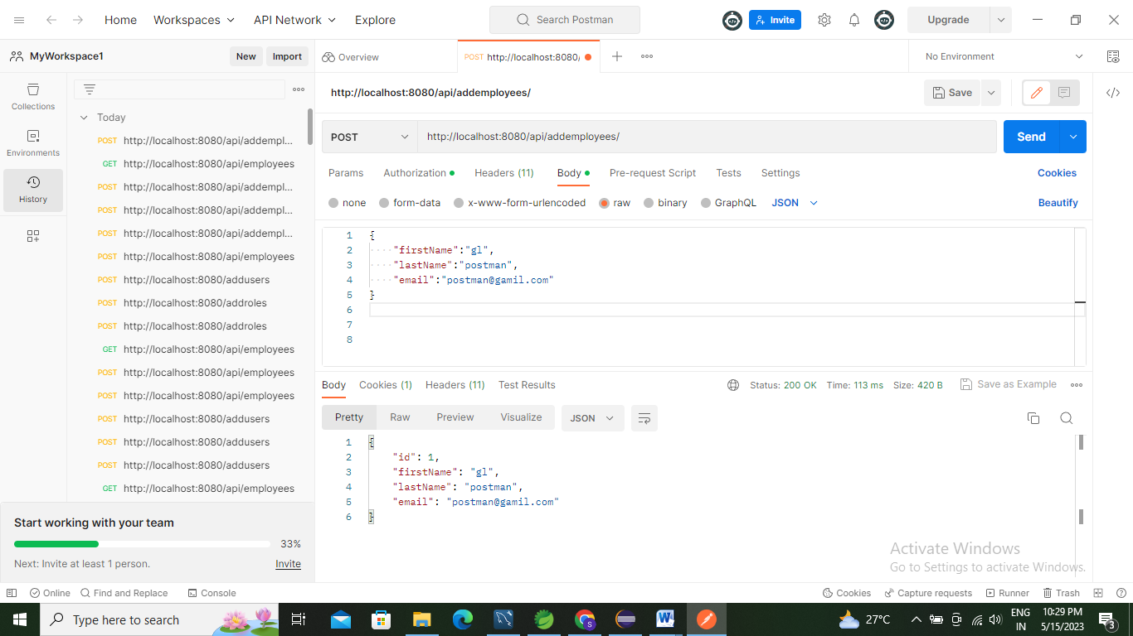

With USER credentials

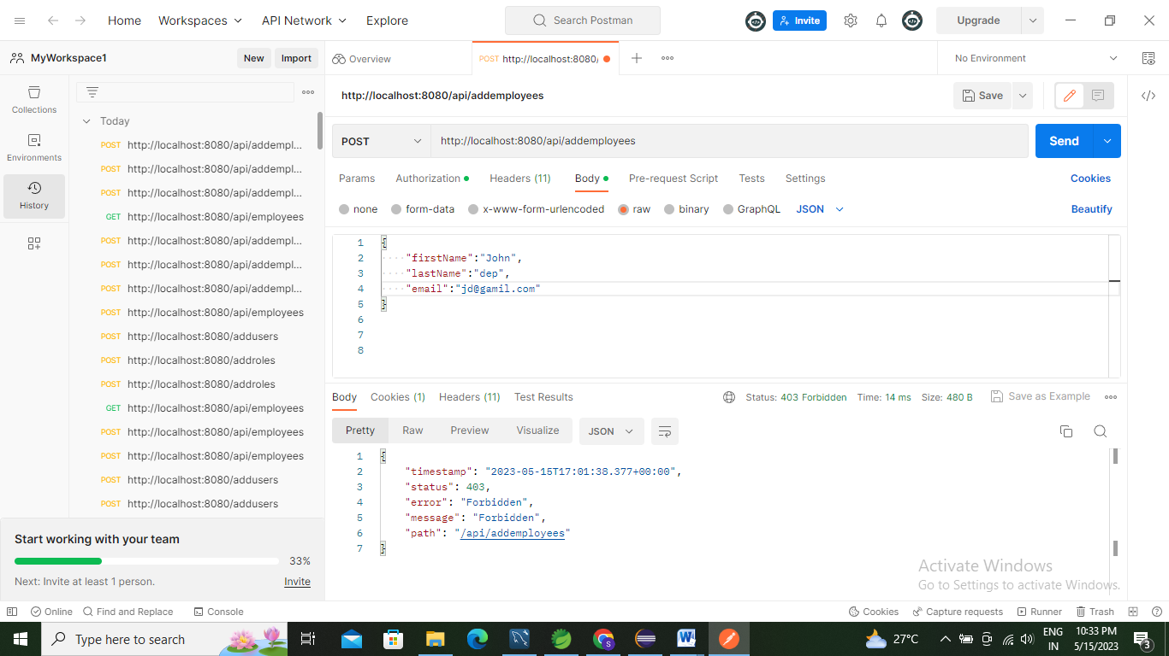

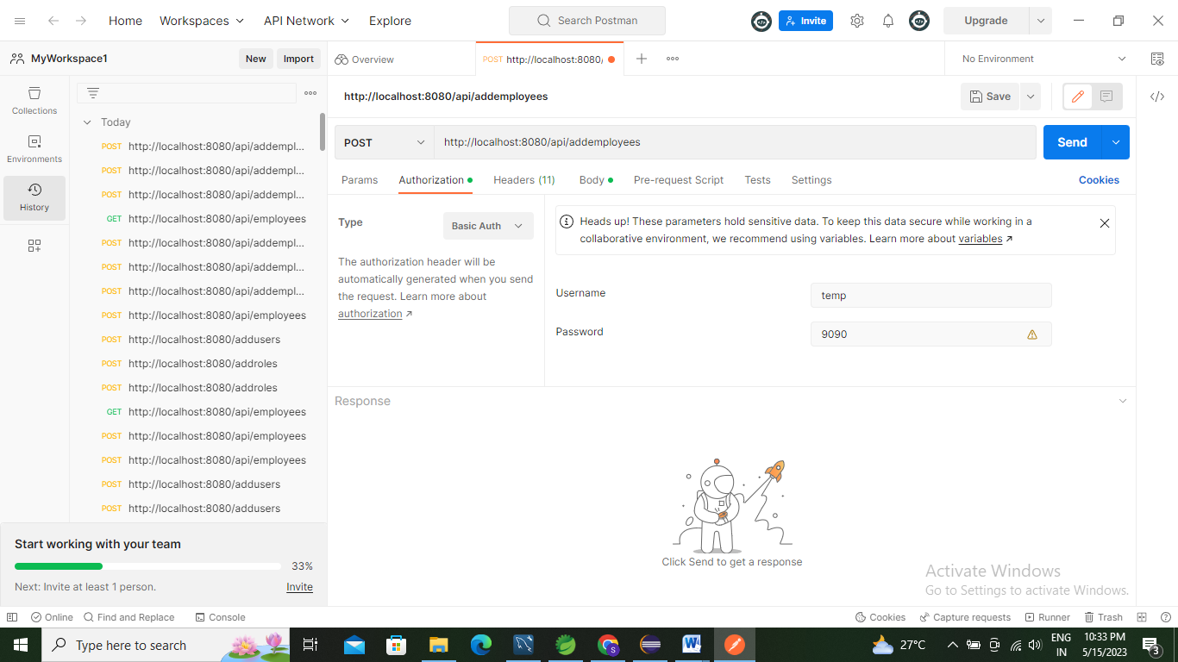

1. List All Employees

http://localhost:8080/api/employees

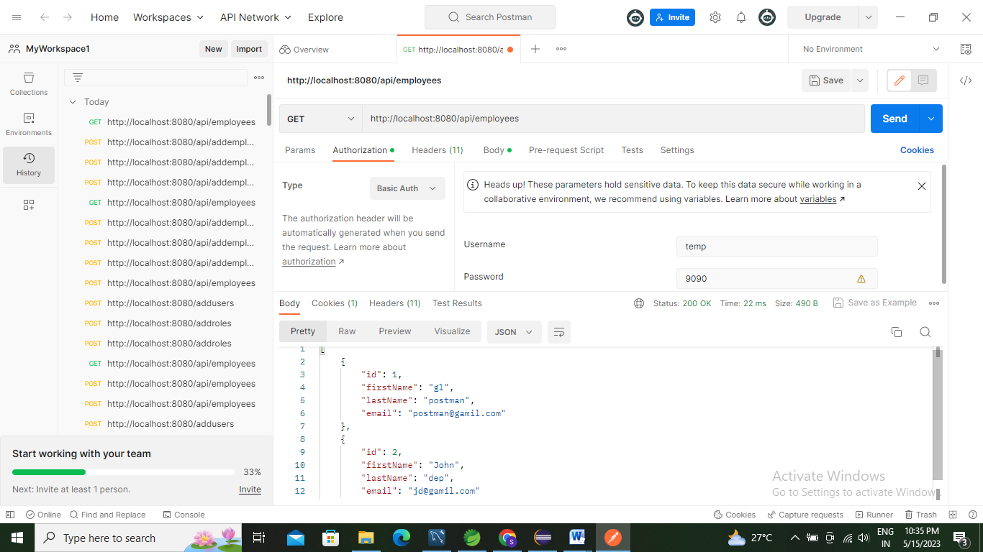

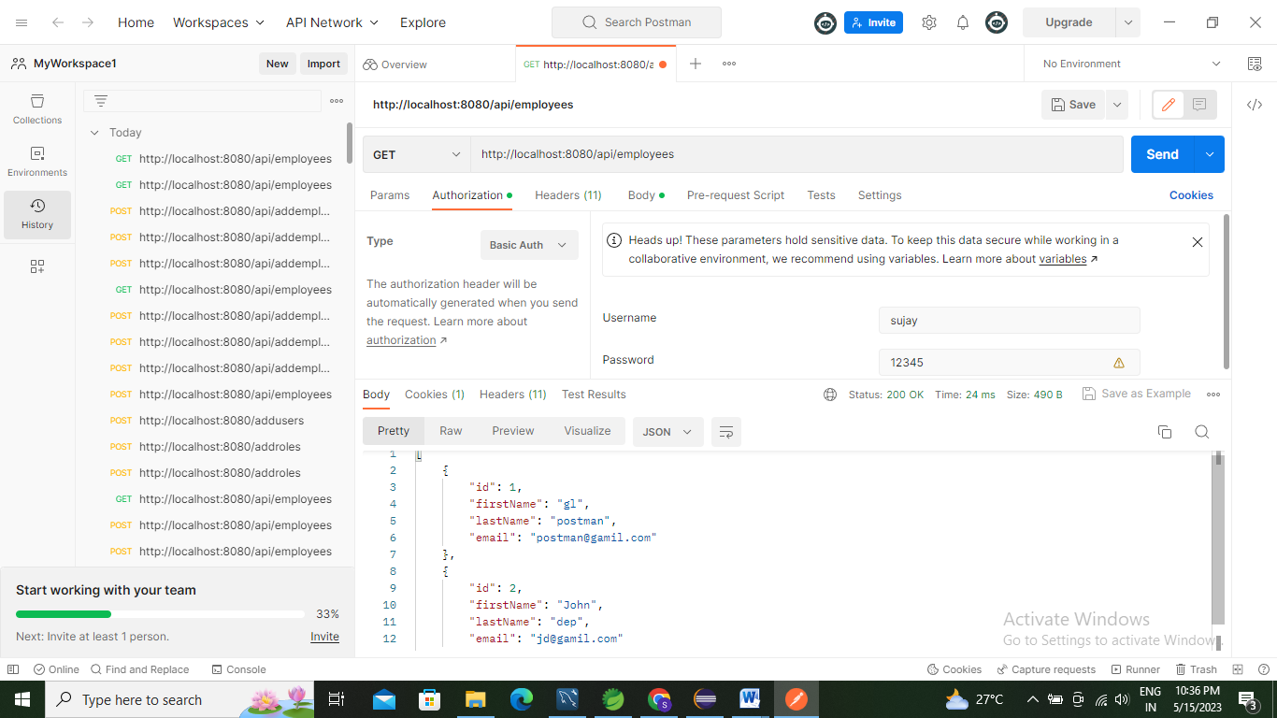

1. Get Employee By ID

http://localhost:8080/api/employees/1

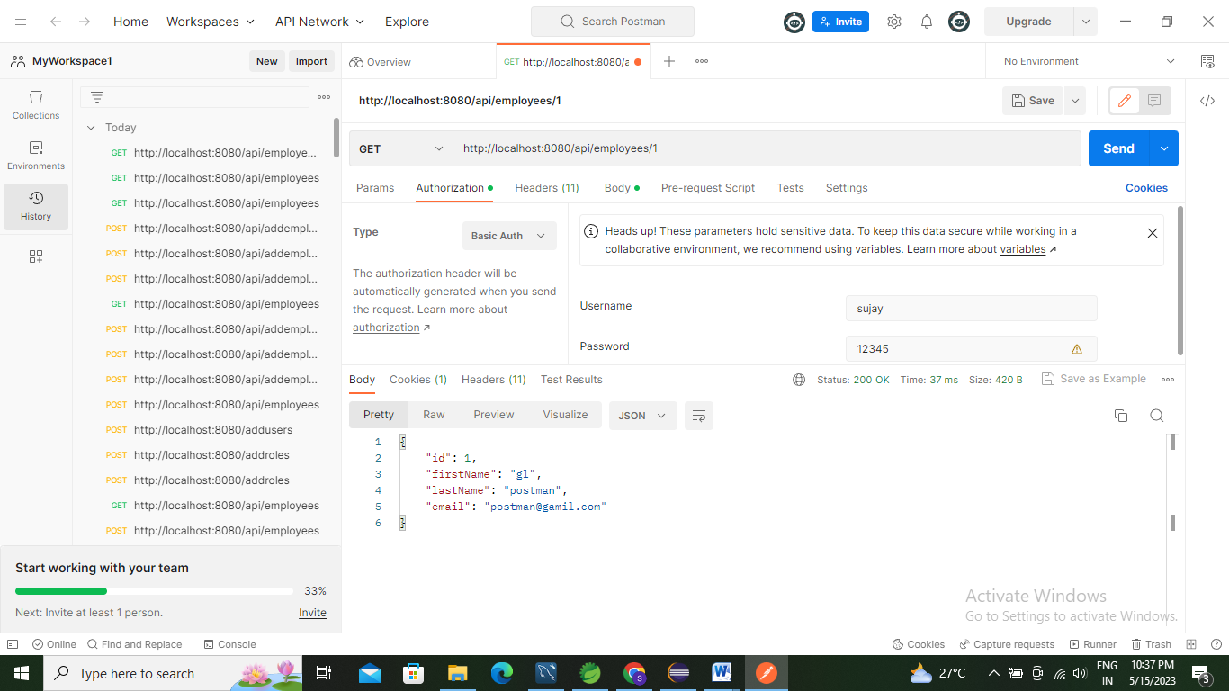

http://localhost:8080/api/employees/2

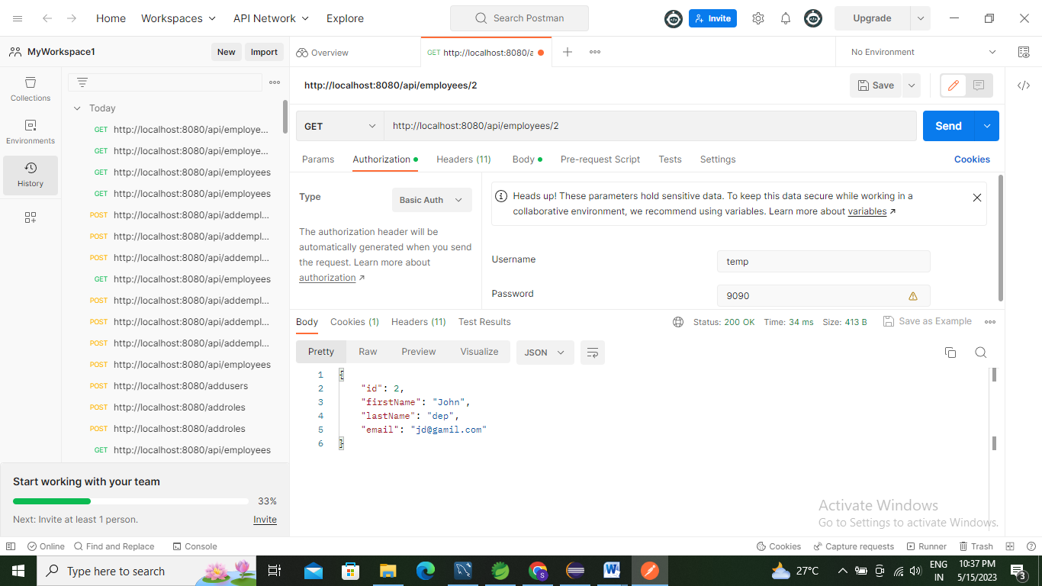

1. **Update Employee**

<http://localhost:8080/api/updateemployees>

Before Update

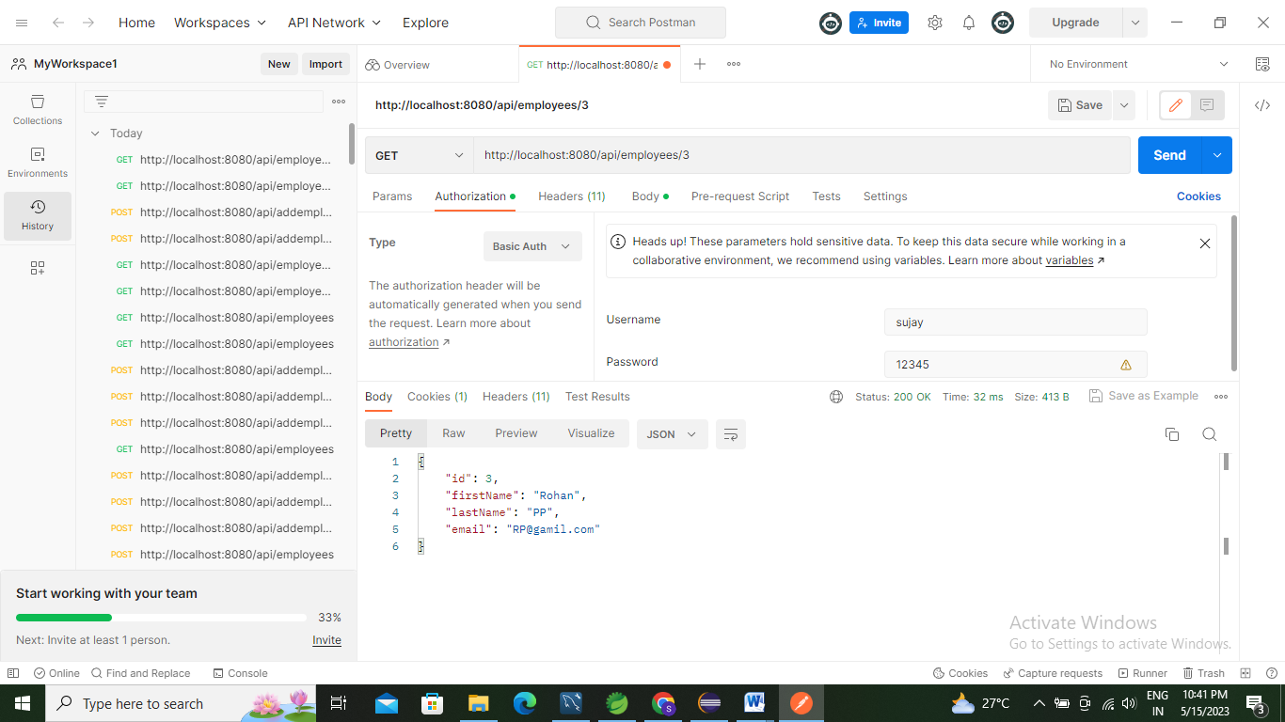

**After Update**

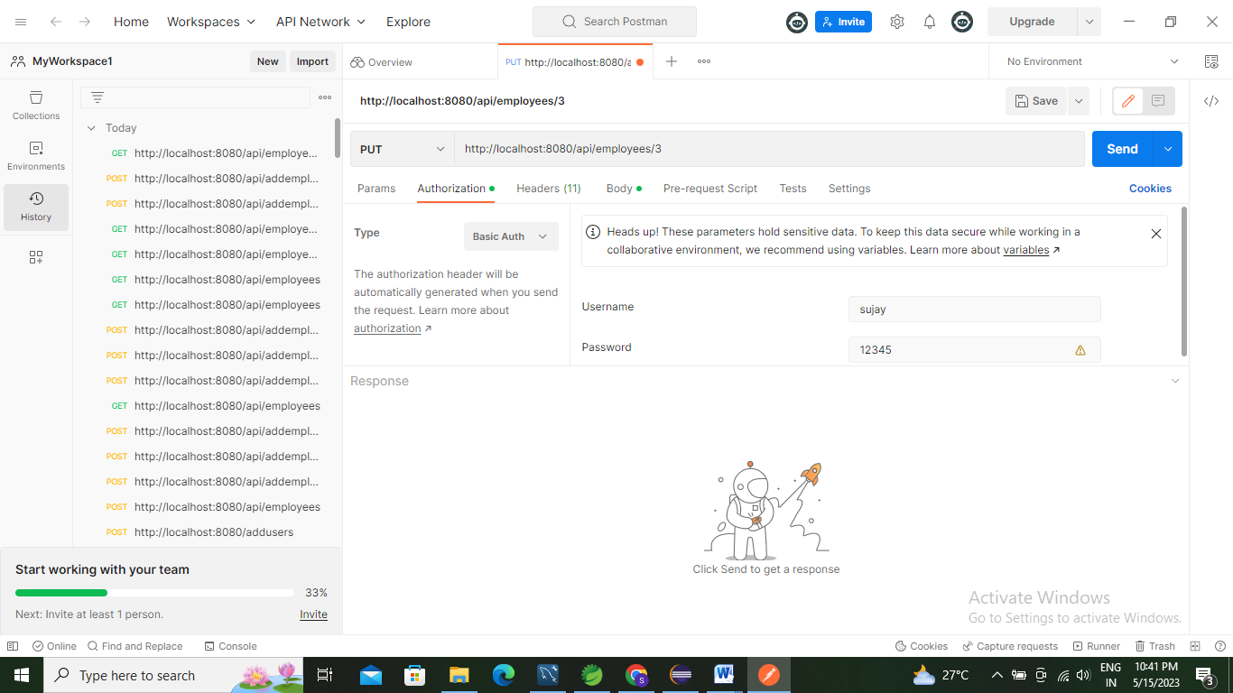

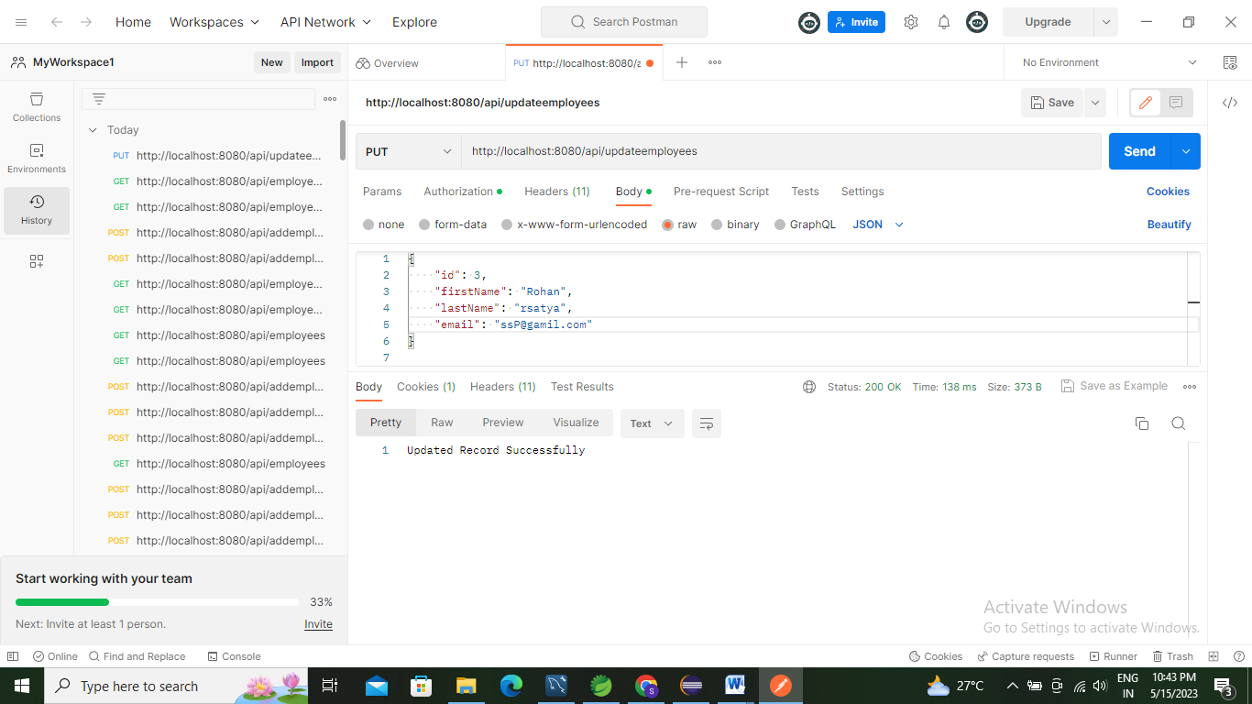

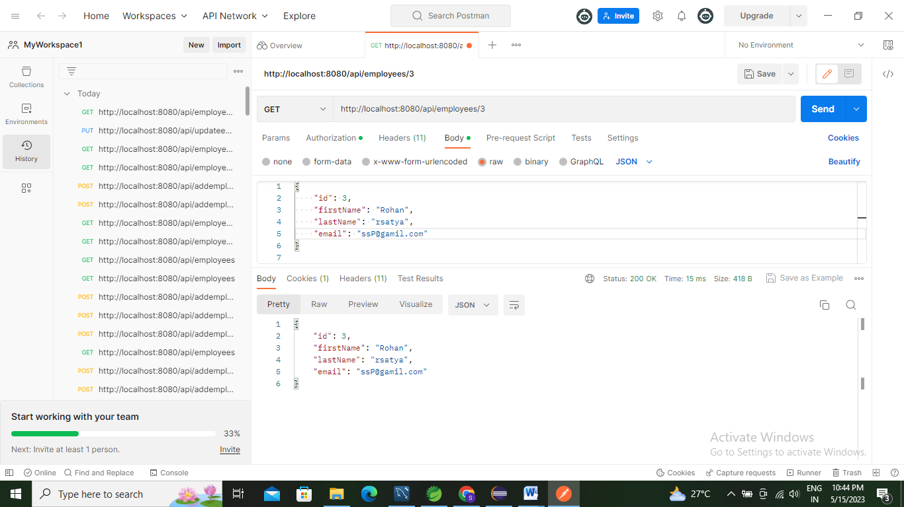

1. **Delete Employee by ID**

http://localhost:8080/api/employees/2

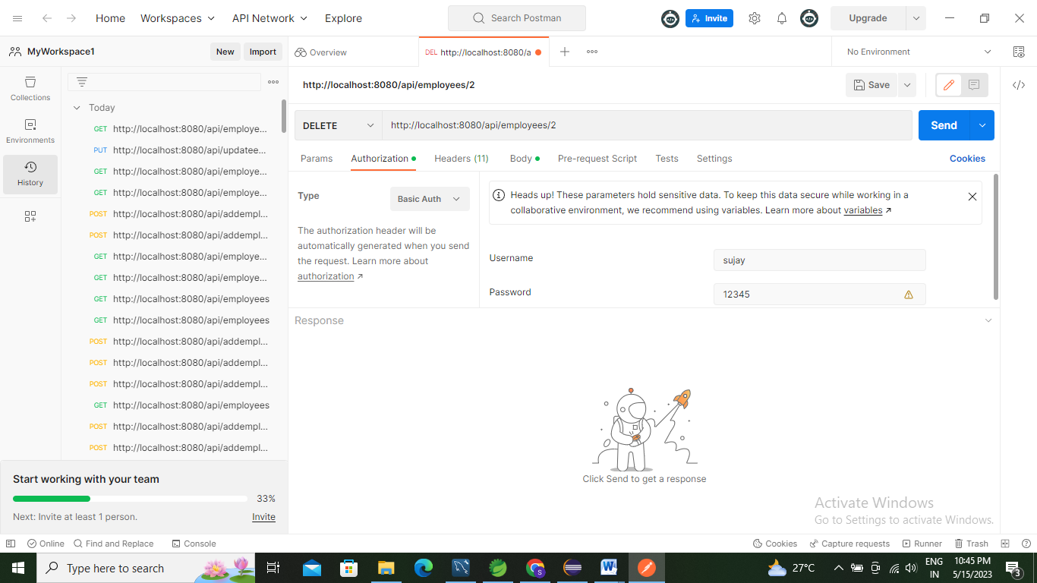

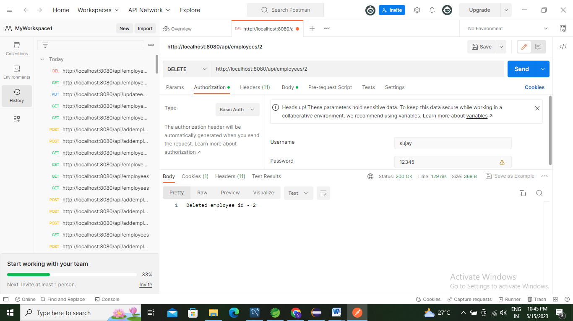

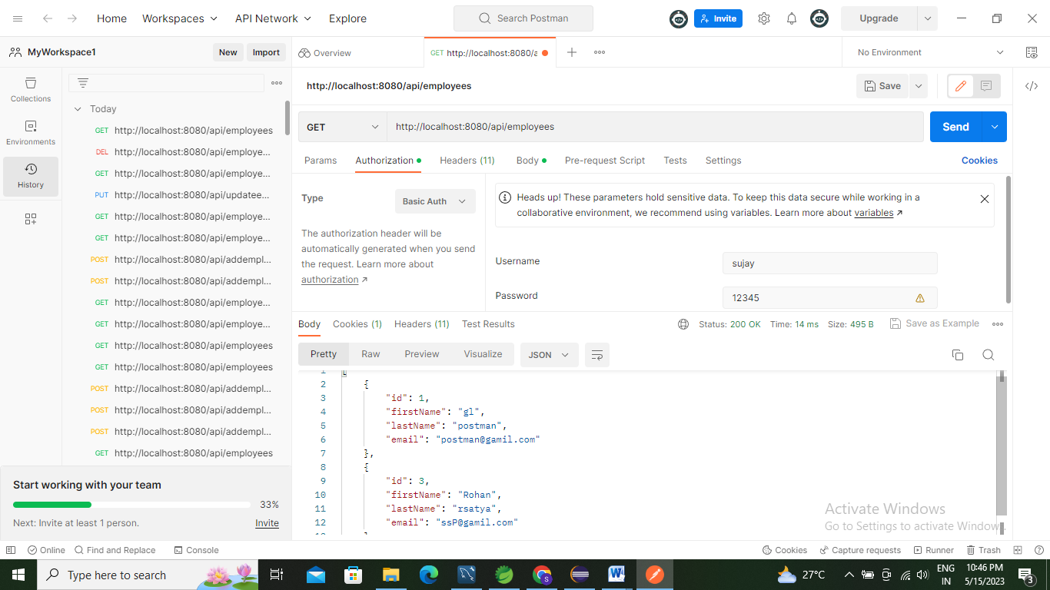

1. **Search by first name**

<http://localhost:8080/api/employees/search/gl>

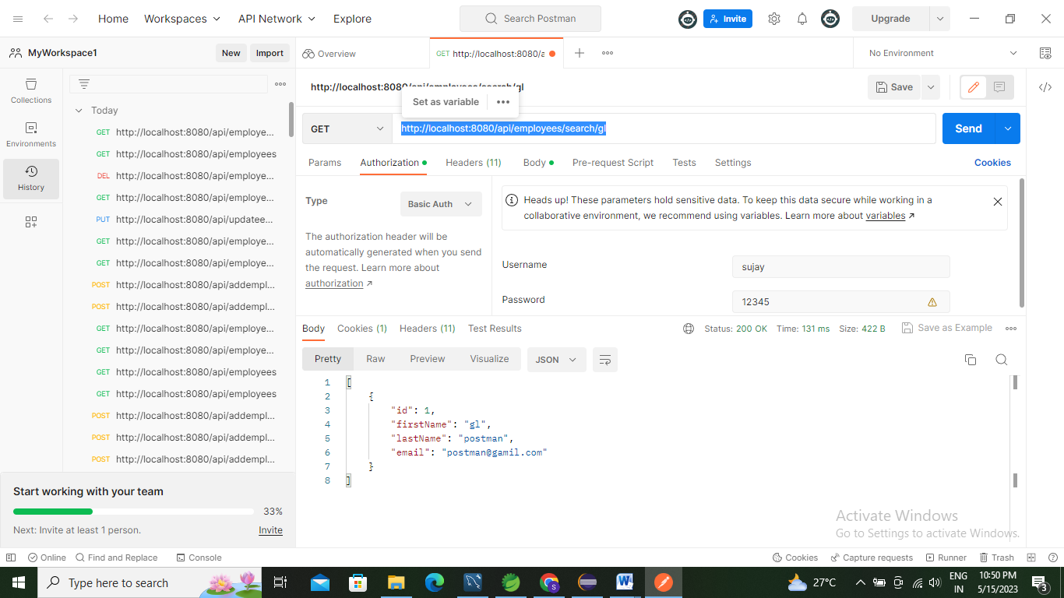

http://localhost:8080/api/employees/search/ro

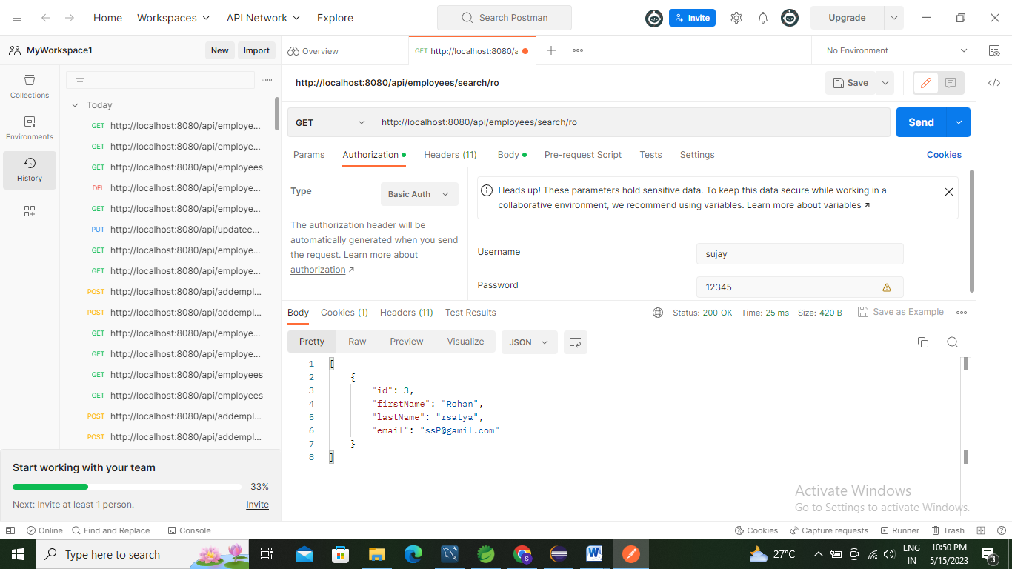

1. **Sort By First Name**

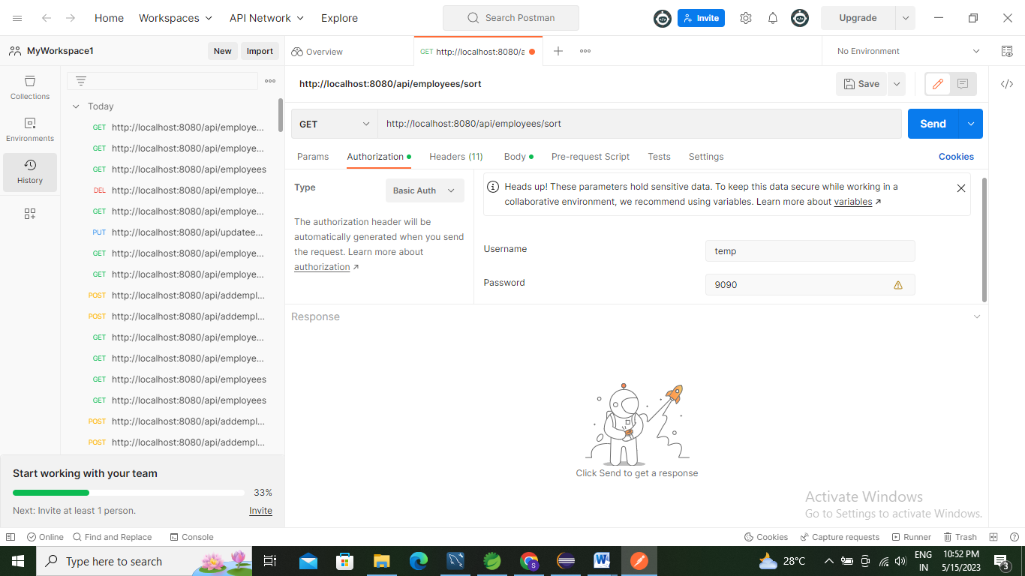

**Ascending Order**

http://localhost:8080/api/employees/sort?order=asc

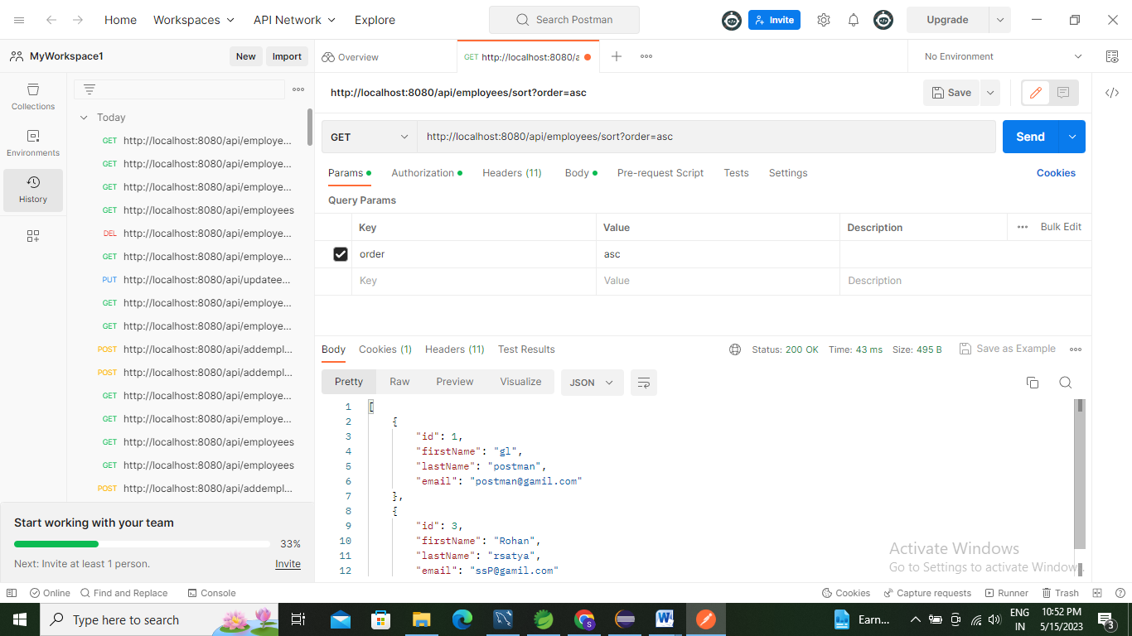

**Descending Order**

http://localhost:8080/api/employees/sort?order=desc

